

Create a web form that accepts a user's name and age. EXP.NO: 4 Write a Servlet to process the form data and display it
back on the browser.

AIM:

To create a simple web application that includes a form to accept a user's name and age, and then use a Servlet to process the submitted data. The Servlet will retrieve the form data, process it, and display the values back on the browser.

ALGORITHM:

1. Input:

• The user fills out a web form with their name and age and submits it.

2. Form Handling and Servlet Processing:

1. Create the Web Form:

o Create an HTML form with two input fields: one for the user's name and one for the user's age.

o Add a submit button to the form.

o Set the form's action attribute to the URL of the Servlet and the method to POST (or GET).

2. Create the Servlet Class:

o Write a Servlet that processes the form data submitted by the user.

o The Servlet will override the doPost() (or doGet() depending on the form method) to handle form submissions.

o The Servlet will retrieve the name and age parameters from the request object using request.getParameter("name") and request.getParameter("age").

3. Process the Data in the Servlet:

o Extract the name and age values submitted from the form.

o Validate the input (e.g., check if the age is a valid number).

o Prepare a response that will display the user's name and age back on the browser.

4. Send Response to the Browser:

o The Servlet will send a response to the browser containing a message like:
▪ "Hello, [name]! You are [age] years old."

o The response will be displayed to the user in the browser.

5. Deploy the Servlet:

o Compile the Servlet and deploy it to a Servlet container (like Apache Tomcat).

o Ensure the web.xml file or Servlet annotations are used to map the Servlet to the URL defined in the form's action attribute.

6. Test the Application:

o Open the web browser, fill in the form with the name and age, and submit it.

o The Servlet will process the data and display the message back to the user in the browser.

HTML File ( index.html ):

<!DOCTYPE html>

<html>

<head>

<title>AIML Department Form</title>

</head>

<body>

<h2>AIML Department - Student Registration Form</h2>

<form action="AIMLServlet" method="post">

Student Name:

<input type="text" name="name" required><br><br>

Register Number:

<input type="text" name="regno" required><br><br>

Year:
<select name="year">

<option>1st Year</option>

<option>2nd Year</option>

<option>3rd Year</option>

<option>4th Year</option>

</select><br><br>

Area of Interest:

<input type="radio" name="interest" value="Artificial Intelligence">AI

<input type="radio" name="interest" value="Machine Learning">ML

<input type="radio" name="interest" value="Deep Learning">DL

<input type="radio" name="interest" value="Data Science">Data Science

<br><br>

<input type="submit" value="Submit">

</form>

</body>

</html>

Java File ( UserServlet.java ) :

import java.io.*;

import jakarta.servlet.*;

import jakarta.servlet.http.*;

import jakarta.servlet.annotation.WebServlet;

@WebServlet("/AIMLServlet")

public class AIMLServlet extends HttpServlet {

protected void doPost(HttpServletRequest request, HttpServletResponse response)
throws ServletException, IOException {

response.setContentType("text/html");

PrintWriter out = response.getWriter();

String name = request.getParameter("name");

String regno = request.getParameter("regno");

String year = request.getParameter("year");

String interest = request.getParameter("interest");

out.println("<html><body>");

out.println("<h2>AIML Department - Student Details</h2>");

out.println("<p><b>Name:</b> " + name + "</p>");

out.println("<p><b>Register No:</b> " + regno + "</p>");

out.println("<p><b>Year:</b> " + year + "</p>");

out.println("<p><b>Area of Interest:</b> " + interest + "</p>");

out.println("<h3>Welcome to AIML Department!</h3>");

out.println("</body></html>");

}

}

File ( web.xml) :
<web-app xmlns="https://jakarta.ee/xml/ns/jakartaee" xmlns:xsi="http://www.w3.org/2001/XMLSchema-instance" xsi:schemaLocation="https://jakarta.ee/xml/ns/jakartaee https://jakarta.ee/xml/ns/jakartaee/web-app_6_0.xsd" version="6.0">

<servlet>
<servlet-name>AIMLServlet</servlet-name> <servlet-class>AIMLServlet</servlet-class>
</servlet>

<servlet-mapping>
<servlet-name>AIMLServlet</servlet-name> <url-pattern>/AIMLServlet</url-pattern>
</servlet-mapping>

</web-app>
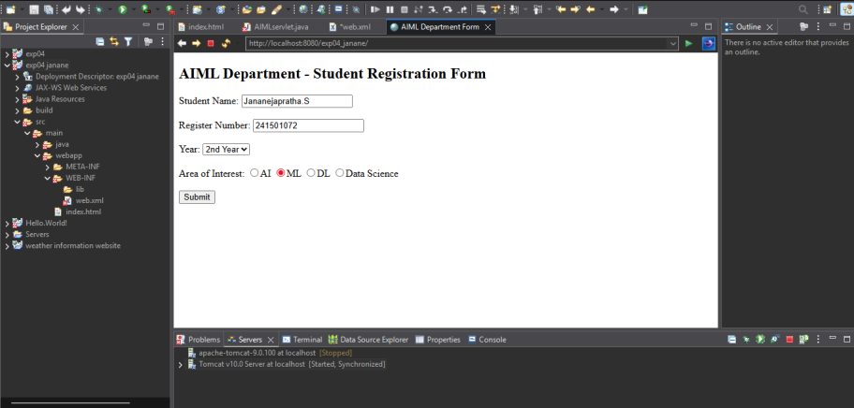
OUTPUT:

RESULT:

Thus A Servlet was created to process the HTML form data and display it back on the browser.

